Alec Schneider

September 20th, 2020

Database Project

## Narrative:

People are struggling to understand their financial health now more than ever due to COVID-19. To better understand how we can improve our future financial well beings we need to understand how our debts, bank, and retirement funds change over time. Spending behaviors can be changed by seeing the effects on balances they have, leading to improved financial standing, better decision making, and long-term wealth accumulation to assist future generations. It is time people log their account balances, incomes, and expenses to receive quick and simple to understand feedback about their financial health in order to create a better world for themselves and others.

## Business Rules

* A person is considered a User the moment they sign up with their information.
* A User can have zero or more than one Account. An Account can only belong to one User.
* A User can have zero or many Cash Flow patterns and a Cash Flow pattern can only belong to one and only one user.
* An Account has one and only one Account Type and an Account type belongs to one and only one Category.
* A Category can have many Account Types and an Account Type can belong to zero or many Accounts.

## Glossary

* **User** – A person who has entered their personal information, and will b
* **Discretionary monthly Income** – Income after taxes
* **Average monthly spending** – average estimated monthly spending
* **Account category** – categorization of the account that describes the general characteristics of the account
  + **Debt** – an obligation to pay money to the creditor who loaned the money
  + **Investment** – an account in which you hold stocks, bonds, mutual funds, or other investment vehicles
  + **Bank** – accounts in which can be easily accessed and withdrawn from.

## What Would I Want To Know?

* What is my debt to income ratio?
  + View of all debt_to_incomes created dbo.debt_to_income_ratios
  + Function created dbo.user_debt_to_income
* What percent of my monthly income am I spending?
  + Created function spend_ratio
* How has spending changed over time?
  + Done for user 650 in python
* How can I create a new user?
  + Done
* How can I add a new account?
  + done
* Can I update my account balance?
* Can I update my cash flow information?
* Can I change my password?
  + done

## Conceptual Model

## Logical Model

## Physical Database Design

### Database creation

use IST659_M401_afschnei;

if object_id('dbo.account_updates') is not null

drop table dbo.account_updates;

if object_id('dbo.accounts') is not null

drop table dbo.accounts;

if object_id('dbo.account_type') is not null

drop table dbo.account_type;

if object_id('dbo.account_category') is not null

drop table dbo.account_category;

if object_id('dbo.cash_flow_updates') is not null

drop table dbo.cash_flow_updates;

if object_id('dbo.cash_flow') is not null

drop table dbo.cash_flow;

if object_id('dbo.user_login') is not null

drop table dbo.user_login

if object_id('dbo.users') is not null

drop table dbo.users;

-- Create table to stored all user information

create table users(

users_id int identity,

first_name varchar(50) not null,

last_name varchar(50) not null,

middle_name varchar(50),

date_of_birth date not null,

social_security varchar(11) not null,

email varchar(150) not null,

gender char(1) not null,

creation_date datetime not null default GetDate(),

-- Constraints

constraint users_pk primary key (users_id),

constraint u1_users unique (social_security),

constraint u2_users unique (email)

);

-- Create login table

create table user_login(

login_id int identity,

users_id int not null,

pass varchar(25) not null

constraint user_login_pk primary key (login_id)

constraint user_login_fk1 foreign key (users_id)

references users(users_id)

)

-- Create table storing the high level account categories

create table account_category(

account_category_id int identity,

account_category_name varchar(20) not null,

constraint account_category_pk primary key (account_category_id),

constraint account_category_u1 unique (account_category_name)

);

-- Create table containing all of the the account types

create table account_type(

account_type_id int identity,

account_type_name varchar(30) not null,

account_category_id int not null,

constraint account_type_pk primary key (account_type_id),

constraint account_type_fk1 foreign key (account_category_id)

references account_category(account_category_id),

constraint account_type_u1 unique (account_type_name)

);

-- Create table that stores all user accounts

create table accounts(

account_id int identity,

account_type_id int not null,

users_id int not null,

constraint account_pk primary key (account_id),

constraint account_fk1 foreign key (account_type_id)

references account_type(account_type_id),

constraint account_fk2 foreign key (users_id)

references users(users_id)

)

-- Create the table to track the account updates over time, and the acount information

create table account_updates(

account_update_id int identity,

balance decimal(9,2) not null,

annual_interest_rate decimal(4,2),

interest_rate_type varchar(8),

repayment_term int,

monthly_payment as Round((balance / repayment_term) * (1 + (annual_interest_rate / 100 / 12)),2),

account_update_date datetime not null default GetDate(),

account_id int not null

constraint account_update_pk primary key (account_update_id)

constraint account_update_fk1 foreign key (account_id)

references accounts(account_id)

);

-- Create table to store cash flows of users

create table cash_flow(

cash_flow_id int identity,

users_id int not null,

constraint cash_flow_pk primary key (cash_flow_id),

constraint cash_flow_fk1 foreign key (users_id)

references users(users_id)

);

-- Create table to track a user's cash flow updates over time

create table cash_flow_updates(

cash_flow_update_id int identity,

discretionary_monthly_income decimal(8,2) not null,

average_monthly_spending decimal(8, 2) not null,

cash_flow_update_date datetime not null default GetDate(),

cash_flow_id int not null,

constraint cash_flow_update_pk primary key (cash_flow_update_id),

constraint cash_flow_update_fk1 foreign key (cash_flow_id)

references cash_flow(cash_flow_id)

);

### Views

-- Views

/*

View that returns a table of all accounts based on their latest update date.

Returrns all of the updated information.

*/

if object_id ('dbo.current_accounts')is not null

drop view dbo.current_accounts

go

create view current_accounts as

select

*

from

(

/* return a table of the accounts ordered by their creation_date

and a row_number field of each cash flow in order to pick the latest one

*/

SELECT

*,

ROW_NUMBER() over (partition by account_id order by account_update_date desc) as RowNum

from

account_updates) as x

WHERE RowNum = 1

go

-- select the view

select * from current_accounts

go

/*

View that returns a table of all user cash flows based on their latest update date.

Returrns all of the updated information.

*/

if object_id ('dbo.current_cash_flows')is not null

drop view dbo.current_cash_flows

go

create view current_cash_flows as

select

*

from

(

/* return a table of the cash_flows ordered by their creation_date

and a row_number field of each cash flow in order to pick the latest one

*/

select

*,

row_number() over (partition by cash_flow_id order by cash_flow_update_date desc) as RowNum

from cash_flow_updates) as x

where RowNum = 1

go

select * from current_cash_flows

go

/*

Return a table of total debt balances by user, using the

current debt accounts

*/

if object_id('dbo.user_debt') is not null

drop view dbo.user_debt

go

create view user_debt as

select

users.users_id,

sum(latest_accounts.balance) as current_total_debt

from

accounts acct

join

users on acct.users_id = users.users_id

join

(

select

account_id,

balance,

account_update_date

from

dbo.current_accounts

) as latest_accounts on latest_accounts.account_id = acct.account_id

join

account_type actype on acct.account_type_id = actype.account_type_id

join

account_category act_cat on actype.account_category_id = act_cat.account_category_id

where

act_cat.account_category_name = 'Debt'

group by users.users_id

go

select * from user_debt order by current_total_debt desc

go

/*

Return a table of total bank balances by user, using the

current bank accounts

*/

if object_id('dbo.user_bank') is not null

drop view dbo.user_bank

go

create view user_bank as

select

users.users_id,

sum(latest_accounts.balance) as current_total_bank_balances

from

accounts acct

join

users on acct.users_id = users.users_id

join

(

select

account_id,

balance,

account_update_date

from

dbo.current_accounts

) as latest_accounts on latest_accounts.account_id = acct.account_id

join

account_type actype on acct.account_type_id = actype.account_type_id

join

account_category act_cat on actype.account_category_id = act_cat.account_category_id

where

act_cat.account_category_name = 'Bank'

group by users.users_id

go

select * from dbo.user_bank

/*

Return a table of total investment balances by user, using the

current investment accounts

*/

if object_id('dbo.user_investment') is not null

drop view dbo.user_investment

go

create view user_investment as

select

users.users_id,

sum(latest_accounts.balance) as current_total_investment_balances

from

accounts acct

join

users on acct.users_id = users.users_id

join

(

select

account_id,

balance,

account_update_date

from

dbo.current_accounts

) as latest_accounts on latest_accounts.account_id = acct.account_id

join

account_type actype on acct.account_type_id = actype.account_type_id

join

account_category act_cat on actype.account_category_id = act_cat.account_category_id

where

act_cat.account_category_name = 'Investment'

group by users.users_id

go

select * from dbo.user_investment

select

users.users_id

from

accounts acct

right join

users on acct.users_id = users.users_id

select

bank.users_id,

bank.current_total_bank_balances,

debt.current_total_debt,

inv.current_total_investment_balances

from

dbo.user_bank bank

join

dbo.user_debt debt on bank.users_id = debt.users_id

join

dbo.user_investment inv on bank.users_id = inv.users_id

select

bank.users_id,

bank.current_total_bank_balances,

debt.current_total_debt,

inv.current_total_investment_balances

from

dbo.user_bank bank

full outer join

dbo.user_debt debt on bank.users_id = debt.users_id

full outer join

dbo.user_investment inv on bank.users_id = inv.users_id

-- user incomes

if object_id('dbo.user_incomes') is not null

drop view dbo.user_incomes

go

create view user_incomes as

select

u.users_id,

cf.cash_flow_id,

latest_income.discretionary_monthly_income

from

cash_flow cf

join

users u on cf.users_id = u.users_id

join

(

select

cash_flow_id,

discretionary_monthly_income

from

dbo.current_cash_flows

) as latest_income on cf.cash_flow_id = latest_income.cash_flow_id

go

select * from user_incomes

go

if object_id('dbo.debt_to_income_ratios') is not null

drop view dbo.debt_to_income_ratios

go

create view debt_to_income_ratios as

select

debt.users_id,

round(debt.current_total_debt/(inc.discretionary_monthly_income *12),2) as debt_to_income_ratio

from

dbo.user_debt debt

join

dbo.user_incomes inc on debt.users_id = inc.users_id

go

select * from debt_to_income_ratios order by debt_to_income_ratio desc

### Functions

-- Function to return the Debt to Income ratio for users

-- get the latest income for each user with a cash_flow

select

u.users_id,

cf.cash_flow_id,

latest_income.discretionary_monthly_income

from

cash_flow cf

join

users u on cf.users_id = u.users_id

join

(

select

cash_flow_id,

discretionary_monthly_income

from

dbo.current_cash_flows

) as latest_income on cf.cash_flow_id = latest_income.cash_flow_id

go

if object_id('dbo.user_debt_to_income') is not null

drop function dbo.user_debt_to_income

go

/*

Find the debt to income ratio of every user

with debt accounts and a cash flow in the

database.

*/

create function dbo.user_debt_to_income(@userID int)

returns decimal(6,2) as

begin

declare @returnVal decimal(6,2)

/*

return a view that calculates the debt to income

ratio for each user. Find only ratio given for the

passed userID.

*/

select

@returnVal = debt_to_income_ratio

from

dbo.debt_to_income_ratios

where users_id = @userID

return @returnVal

end

go

-- Run the function for all users

select

users_id,

first_name,

last_name,

dbo.user_debt_to_income(users_id) as debt_to_income_ratio

from

users

order by debt_to_income_ratio desc

go

if object_id('dbo.spend_ratio') is not null

drop function dbo.spend_ratio

go

create function dbo.spend_ratio(@userID int)

returns decimal(6,2) as

begin

declare @returnVal decimal(6,2)

select

@returnVal = round(average_monthly_spending / discretionary_monthly_income, 2)*100

from

dbo.current_cash_flows curr_cf

join

cash_flow on curr_cf.cash_flow_id = cash_flow.cash_flow_id

where cash_flow.users_id = @userID

return @returnVal

end

go

select

*,

dbo.spend_ratio(users_id) as spending_to_income_percent

from

users

order by spending_to_income_percent desc

### What is my debt to income ratio?

Two ways to achieve

create view debt_to_income_ratios as

select

debt.users_id,

round(debt.current_total_debt/(inc.discretionary_monthly_income *12),2) as debt_to_income_ratio

from

dbo.user_debt debt

join

dbo.user_incomes inc on debt.users_id = inc.users_id

go

if object_id('dbo.user_debt_to_income') is not null

drop function dbo.user_debt_to_income

go

/*

Find the debt to income ratio of every user

with debt accounts and a cash flow in the

database.

*/

create function dbo.user_debt_to_income(@userID int)

returns decimal(6,2) as

begin

declare @returnVal decimal(6,2)

/*

return a view that calculates the debt to income

ratio for each user. Find only ratio given for the

passed userID.

*/

select

@returnVal = debt_to_income_ratio

from

dbo.debt_to_income_ratios

where users_id = @userID

return @returnVal

end

go

-- Run the function for all users

select

users_id,

first_name,

last_name,

dbo.user_debt_to_income(users_id) as debt_to_income_ratio

from

users

order by debt_to_income_ratio desc

go

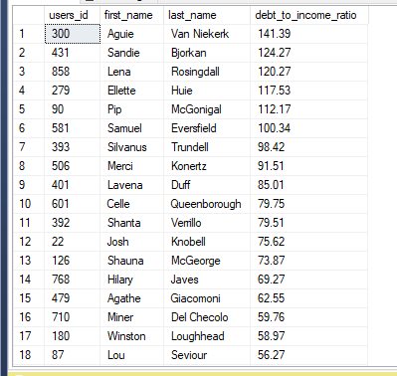

### What percent of my monthly income am I spending?

create function dbo.spend_ratio(@userID int)

returns decimal(6,2) as

begin

declare @returnVal decimal(6,2)

select

@returnVal = round(average_monthly_spending / discretionary_monthly_income, 2)*100

from

dbo.current_cash_flows curr_cf

join

cash_flow on curr_cf.cash_flow_id = cash_flow.cash_flow_id

where cash_flow.users_id = @userID

return @returnVal

end

go

select

*,

dbo.spend_ratio(users_id) as spending_to_income_percent

from

users

order by spending_to_income_percent desc

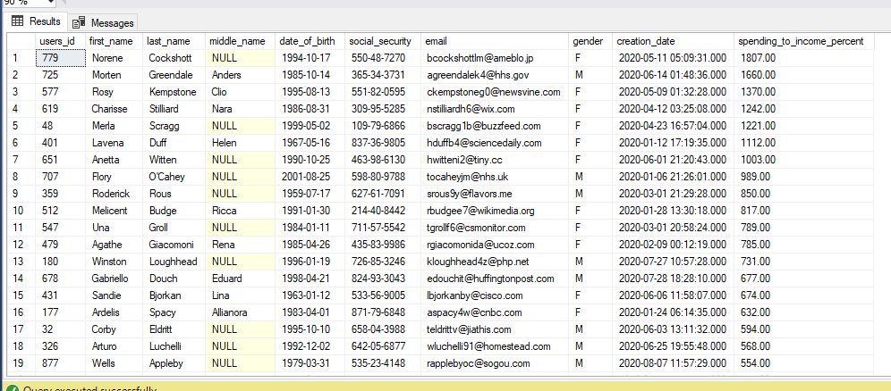

### How has spending changed over time?

Used the below query in python and looked at user 650’s spending behavior over time.

select

*,

row_number() over (partition by cash_flow_updates.cash_flow_id order by

cash_flow_updates.cash_flow_update_date desc) as RowNum

from

cash_flow_updates

join

cash_flow on cash_flow.cash_flow_id = cash_flow_updates.cash_flow_id

### How can I create new users?

-- Create a new user and enter their login info into the user_login table

create procedure new_user(@fname varchar(50), @lname varchar(50), @mname varchar(50) = Null,

@dob date, @ss varchar(11), @email varchar(150), @gender char(1),

@pass varchar(25))

as

begin

-- insert new user into the users table

insert into users

(first_name, last_name, middle_name, date_of_birth, social_security, email, gender)

values

(@fname, @lname, @mname, @dob, @ss, @email, @gender)

-- insert login information into user_login

insert into user_login

(users_id, pass)

values

(@@identity, @pass)

end

go

Created a website gui using python and html to enter information into the procedure:

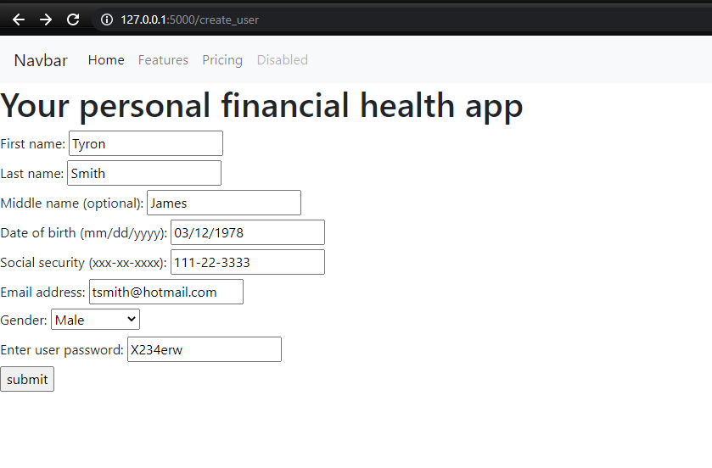

-- Check results after creting a user through the flask based app via python

select top 1 * from users order by users_id desc

select * from user_login where users_id = (select top 1 users_id from users order by users_id desc)

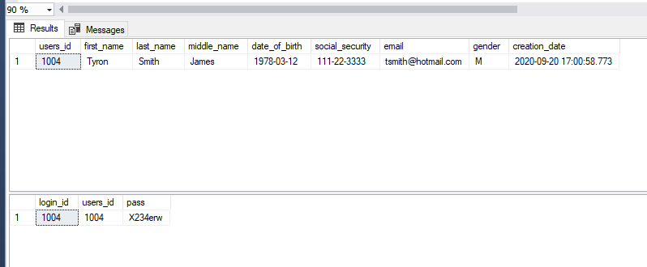

### How can I add a new account?

-- create an account for an existing user

create procedure create_account(@users_id int, @acc_type_name varchar(30), @bal decimal(9,2), @rate decimal(4,2) = Null,

@rate_type varchar(8) = Null, @term int = Null)

as

begin

-- begin transaction

begin try

begin transaction

-- declare account id to be defined later

declare @acct_id int

-- return the account type id to enter into the accounts table

declare @acc_type int = (select account_type_id

from account_type

where account_type_name = @acc_type_name)

-- create the account in the accounts table

insert into accounts

(account_type_id, users_id)

values

(@acc_type, @users_id)

-- set the row identity to account is

set @acct_id = @@identity

-- execute the account update procedure to enter the account info

exec update_account @acct_id=@acct_id, @bal=@bal, @rate=@rate,

@rate_type=@rate_type, @term=@term

if @@TRANCOUNT > 0

commit

end try

begin catch

if @@TRANCOUNT > 0

rollback

SELECT

ERROR_NUMBER() AS ErrorNumber,

ERROR_MESSAGE() AS ErrorMessage

end catch

end

go

Created a website gui using python and html to enter new accounts into the procedure:

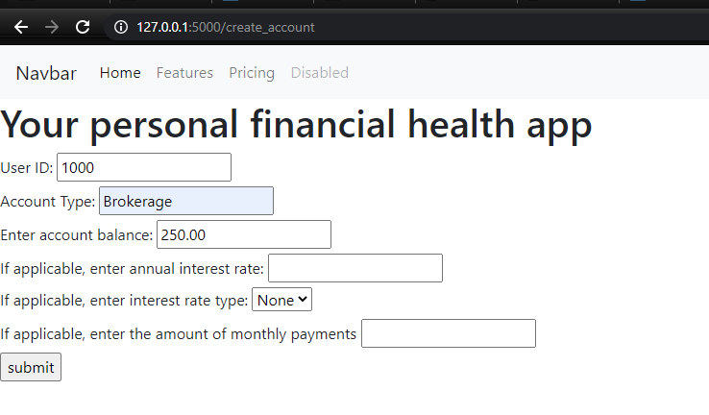

-- Check results after entering an account through the flask based app via python

select top 1 * from accounts order by account_id desc

select

*

from

current_accounts

where account_id in (select top 1

account_id

from accounts

order by account_id desc)

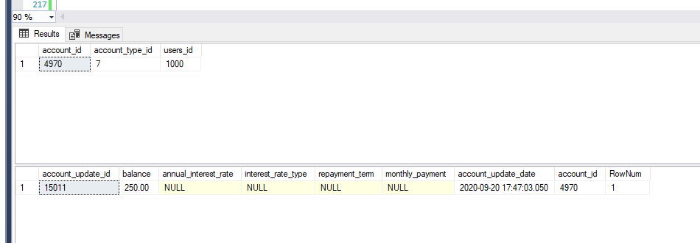

### Can I update my account balance?

-- Create procedure to update accounts

create procedure update_account(@acct_id int, @bal decimal(9,2), @rate decimal(4,2) = Null, @rate_type varchar(8) = Null,

@term int = Null)

as

begin

-- update the information provided

insert into account_updates

(account_id ,balance, annual_interest_rate, interest_rate_type,

repayment_term)

values

(@acct_id, @bal, @rate, @rate_type, @term)

end

go

exec update_account @acct_id=1589, @bal=343322.1

select * from account_updates where account_id = 1589

go

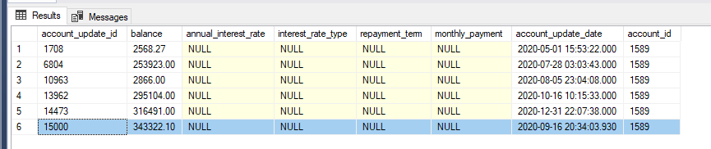

### Can I update my cash flow information?

-- Create procedure to update cash flow of a user

create procedure update_cash_flow(@cf_id int, @income decimal(8,2), @spend decimal(8,2))

as

begin

-- insert new cash flow update

insert into cash_flow_updates

(cash_flow_id, discretionary_monthly_income, average_monthly_spending)

values

(@cf_id, @income, @spend)

end

go

exec update_cash_flow 593, 15000, 10000

select * from cash_flow_updates where cash_flow_id = 593

go

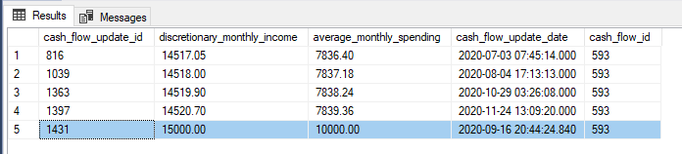

### Can I change my password?

-- update a user's password

create procedure update_password(@user_id int, @pass varchar(25))

as

begin

-- update the user's login password

update

user_login

set

pass = @pass

where

users_id = @user_id

end

go

exec update_password 1, icecold23

select * from user_login where users_id = 1

